For instructions on using this template, please see Notes to Author/Template Instructions on page iv. Notes on accessibility: This template has been tested and is best accessible with JAWS 11.0 or higher. For questions about using this template, please contact [CMS IT Governance](mailto:IT_Governance@cms.hhs.gov) ([IT_Governance@cms.hhs.gov](mailto:IT_Governance@cms.hhs.gov)). To request changes to the template, please submit an [XLC Process Change Request](https://www.cms.gov/Research-Statistics-Data-and-Systems/CMS-Information-Technology/XLC/Downloads/XLCProcessChangeRequestCR.docx) (CR) (<https://www.cms.gov/Research-Statistics-Data-and-Systems/CMS-Information-Technology/XLC/Downloads/XLCProcessChangeRequestCR.docx>).

<SISTEM PENDAFTARAN GYM>

# Operations & Maintenance (O&M) Manual

Version X.X

MM/DD/YYYY

Document Number: <document’s configuration item control number>

Contract Number: <current contract number of company maintaining document>

Manual Pengguna

LOGIN.HTML

|  |
| --- |
| <!DOCTYPE html>  <html lang="en">  <head>  <title>Login V1</title>  <meta charset="UTF-8">  <meta name="viewport" content="width=device-width, initial-scale=1">  <!--===============================================================================================-->  <link rel="icon" type="image/png" href="images/icons/favicon.ico"/>  <!--===============================================================================================-->  <link rel="stylesheet" type="text/css" href="vendor/bootstrap/css/bootstrap.min.css">  <!--===============================================================================================-->  <link rel="stylesheet" type="text/css" href="fonts/font-awesome-4.7.0/css/font-awesome.min.css">  <!--===============================================================================================-->  <link rel="stylesheet" type="text/css" href="vendor/animate/animate.css">  <!--===============================================================================================-->  <link rel="stylesheet" type="text/css" href="vendor/css-hamburgers/hamburgers.min.css">  <!--===============================================================================================-->  <link rel="stylesheet" type="text/css" href="vendor/select2/select2.min.css">  <!--===============================================================================================-->  <link rel="stylesheet" type="text/css" href="css/util.css">  <link rel="stylesheet" type="text/css" href="css/main.css">  <!--===============================================================================================-->  </head>  <body>    <div class="limiter">  <div class="container-login100">  <div class="wrap-login100">  <div class="login100-pic js-tilt" data-tilt>  <img src="images/img-01.png" alt="IMG">  </div>  <form class="login100-form validate-form">  <span class="login100-form-title">  Member Login  </span>  <div class="wrap-input100 validate-input" data-validate = "Valid email is required: ex@abc.xyz">  <input class="input100" type="text" name="email" placeholder="Email">  <span class="focus-input100"></span>  <span class="symbol-input100">  <i class="fa fa-envelope" aria-hidden="true"></i>  </span>  </div>  <div class="wrap-input100 validate-input" data-validate = "Password is required">  <input class="input100" type="password" name="pass" placeholder="Password">  <span class="focus-input100"></span>  <span class="symbol-input100">  <i class="fa fa-lock" aria-hidden="true"></i>  </span>  </div>    <div class="container-login100-form-btn">  <button class="login100-form-btn">  Login  </button>  </div>  <div class="text-center p-t-12">  <span class="txt1">  Forgot  </span>  <a class="txt2" href="#">  Username / Password?  </a>  </div>  <div class="text-center p-t-136">  <a class="txt2" href="#">  Create your Account  <i class="fa fa-long-arrow-right m-l-5" aria-hidden="true"></i>  </a>  </div>  </form>  </div>  </div>  </div>        <!--===============================================================================================-->  <script src="vendor/jquery/jquery-3.2.1.min.js"></script>  <!--===============================================================================================-->  <script src="vendor/bootstrap/js/popper.js"></script>  <script src="vendor/bootstrap/js/bootstrap.min.js"></script>  <!--===============================================================================================-->  <script src="vendor/select2/select2.min.js"></script>  <!--===============================================================================================-->  <script src="vendor/tilt/tilt.jquery.min.js"></script>  <script >  $('.js-tilt').tilt({  scale: 1.1  })  </script>  <!--===============================================================================================-->  <script src="js/main.js"></script>  </body>  </html> |

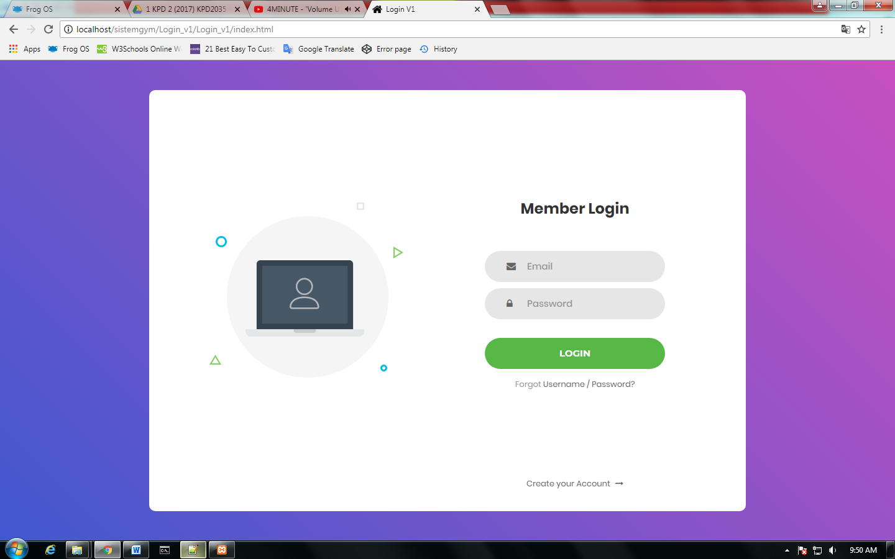

ADD.HTML

|  |
| --- |
| <head>  <meta charset="utf-8">  <meta name="viewport" content="width=device-width, initial-scale=1.0">  <title>Daftar Pelanggan</title>  <link rel="stylesheet" href="css/normalize.css">  <link href='https://fonts.googleapis.com/css?family=Nunito:400,300' rel='stylesheet' type='text/css'>  <link rel="stylesheet" href="css/main.css">  </head>  <body>  <style>*, *:before, *:after {  -moz-box-sizing: border-box;  -webkit-box-sizing: border-box;  box-sizing: border-box;  }  body {  font-family: 'Nunito', sans-serif;  color: #384047;  }  form {  max-width: 300px;  margin: 10px auto;  padding: 10px 20px;  background: #f4f7f8;  border-radius: 8px;  }  h1 {  margin: 0 0 30px 0;  text-align: center;  }  input[type="text"],  input[type="password"],  input[type="date"],  input[type="datetime"],  input[type="email"],  input[type="number"],  input[type="search"],  input[type="tel"],  input[type="time"],  input[type="url"],  textarea,  select {  background: rgba(255,255,255,0.1);  border: none;  font-size: 16px;  height: auto;  margin: 0;  outline: 0;  padding: 15px;  width: 100%;  background-color: #e8eeef;  color: #8a97a0;  box-shadow: 0 1px 0 rgba(0,0,0,0.03) inset;  margin-bottom: 30px;  }  input[type="radio"],  input[type="checkbox"] {  margin: 0 4px 8px 0;  }  select {  padding: 6px;  height: 32px;  border-radius: 2px;  }  button {  padding: 19px 39px 18px 39px;  color: #FFF;  background-color: #4bc970;  font-size: 18px;  text-align: center;  font-style: normal;  border-radius: 5px;  width: 100%;  border: 1px solid #3ac162;  border-width: 1px 1px 3px;  box-shadow: 0 -1px 0 rgba(255,255,255,0.1) inset;  margin-bottom: 10px;  }  fieldset {  margin-bottom: 30px;  border: none;  }  legend {  font-size: 1.4em;  margin-bottom: 10px;  }  label {  display: block;  margin-bottom: 8px;  }  label.light {  font-weight: 300;  display: inline;  }  .number {  background-color: #5fcf80;  color: #fff;  height: 30px;  width: 30px;  display: inline-block;  font-size: 0.8em;  margin-right: 4px;  line-height: 30px;  text-align: center;  text-shadow: 0 1px 0 rgba(255,255,255,0.2);  border-radius: 100%;  }  @media screen and (min-width: 480px) {  form {  max-width: 480px;  }  }  </style>  <form action="index.html" method="post">    <h1>DAFTAR PELANGGAN BANDAR BARU UDA GYM CLASS</h1>    <fieldset>  <legend><span class="number">1</span>Maklumat Pelanggan</legend>  <label for="name">NAMA PENUH:</label>  <input type="text" id="name" name="user_name">    <label for="mail">EMAIL:</label>  <input type="email" id="mail" name="user_email">    <label for="password">ALAMAT TERKINI:</label>  <input type="password" id="password" name="user_password">    <label>UMUR:</label>  <input type="radio" id="under_17" value="under_17" name="user_age"><label for="under_13" class="light">Under 17</label><br>  <input type="radio" id="over_17" value="over_17" name="user_age"><label for="over_13" class="light">17 or older</label>  </fieldset>    <fieldset>  <legend><span class="number">2</span>PROFIL PELANGGAN</legend>  <label for="bio">Biography:</label>  <textarea id="bio" name="user_bio"></textarea>  </fieldset>  <fieldset>      </fieldset>  <button type="submit">DAFTAR ANDA</button>  </form>    </body>  </html> |

